# CHAPTER FOUR: RESULTS AND DISCUSSIONS

## 4.0 Introduction

This chapter presents and discusses the key outcomes of the Fashion Hubplatform, emphasizing the visual outputs, system features, user interface designs, and technical implementations that were achieved during the development phase. The platform was developed based on the findings from Chapters One through Three, including problem identification, user needs analysis, and system architecture planning.

The results are structured around major system components, showcasing how each feature fulfills a corresponding user need. These include vendor registration, product management, secure payment integration, AI-assisted chatbot support, and mobile optimization. Pictorial views in the form of UI screenshots illustrate the practical implementation of these features in both desktop and mobile views.

In addition to visual demonstrations, the chapter provides a walkthrough of real user interactions with the system. This includes customer experiences browsing and buying fashion products, vendor experiences managing inventories and orders, and admin controls overseeing platform activity.

Initial testing and feedback were gathered through informal usability sessions involving boutique owners and fashion designers in Sekondi-Takoradi. These users were selected based on their involvement in earlier community engagements and their relevance to the platform’s target audience. Their interactions with the system offered critical insights into usability, relevance of features, clarity of interface, and overall satisfaction.

Furthermore, the discussion in this chapter is structured to address the research questions outlined in Chapter One. By directly relating system results to these questions, the chapter not only evaluates how well the platform meets its goals but also provides insights into the effectiveness of the Fashion Hubapproach in solving the challenges faced by fashion SMEs in Takoradi.

Overall, this chapter serves as both a presentation of technical accomplishments and a validation of the system’s real-world relevance, through feedback, system outputs, and alignment with user expectations.

## 4.2 Results – Pictorial Views of System Components

This section presents visual outputs of the key components of the Fashion Hubplatform. It includes screenshots of interfaces such as the homepage, product listings, vendor dashboard, checkout page, and chatbot. Each image highlights core functionalities and demonstrates how users interact with the system across different roles.

**4.2.1 Registration and Login**

Boutique owners and customers can register by providing their name, contact details, and shop information. Once logged in, the dashboard provides access to product uploads, order management, and analytics.

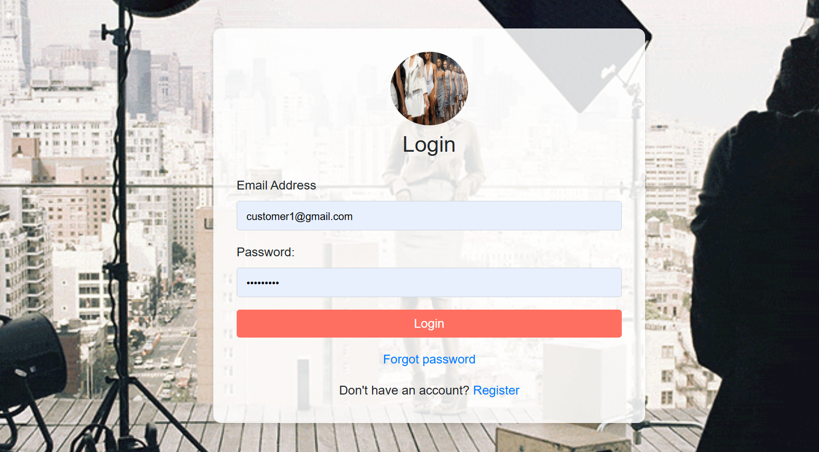

**4.2.2 Customer’s Home Page and Product Listings**

The homepage features a clean, mobile-optimized interface that allows users to browse fashion products using search and category filters. Products are displayed with thumbnails, names, and prices. It provides intuitive navigation for customers to discover trending outfits.  
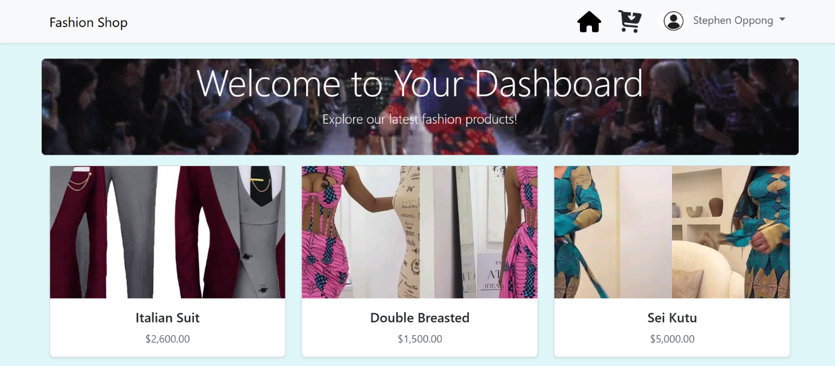

**4.2.3 Vendor Dashboard**  
The vendor dashboard shows options like “Add Product,” “Manage Orders,” and a summary of total sales. A navigation sidebar improves accessibility.

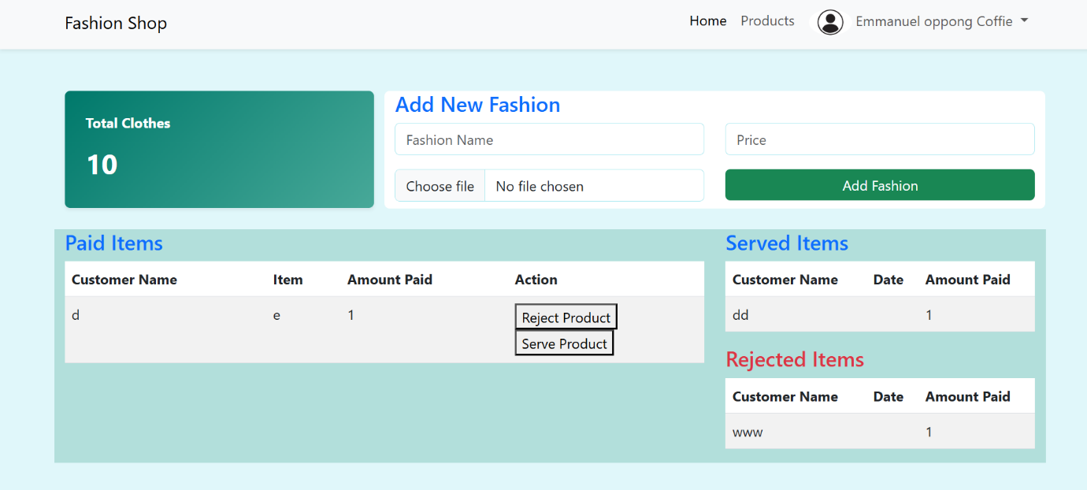

**4.2.4 Product Upload Page**

Designers can upload fashion items by filling out a form with product name, category, description, price, and an image. Images are stored securely and rendered on the customer-facing product page.

The interface uses Laravel Blade forms with image previews. Fields are validated before submission. Successful uploads are confirmed with a toast notification.

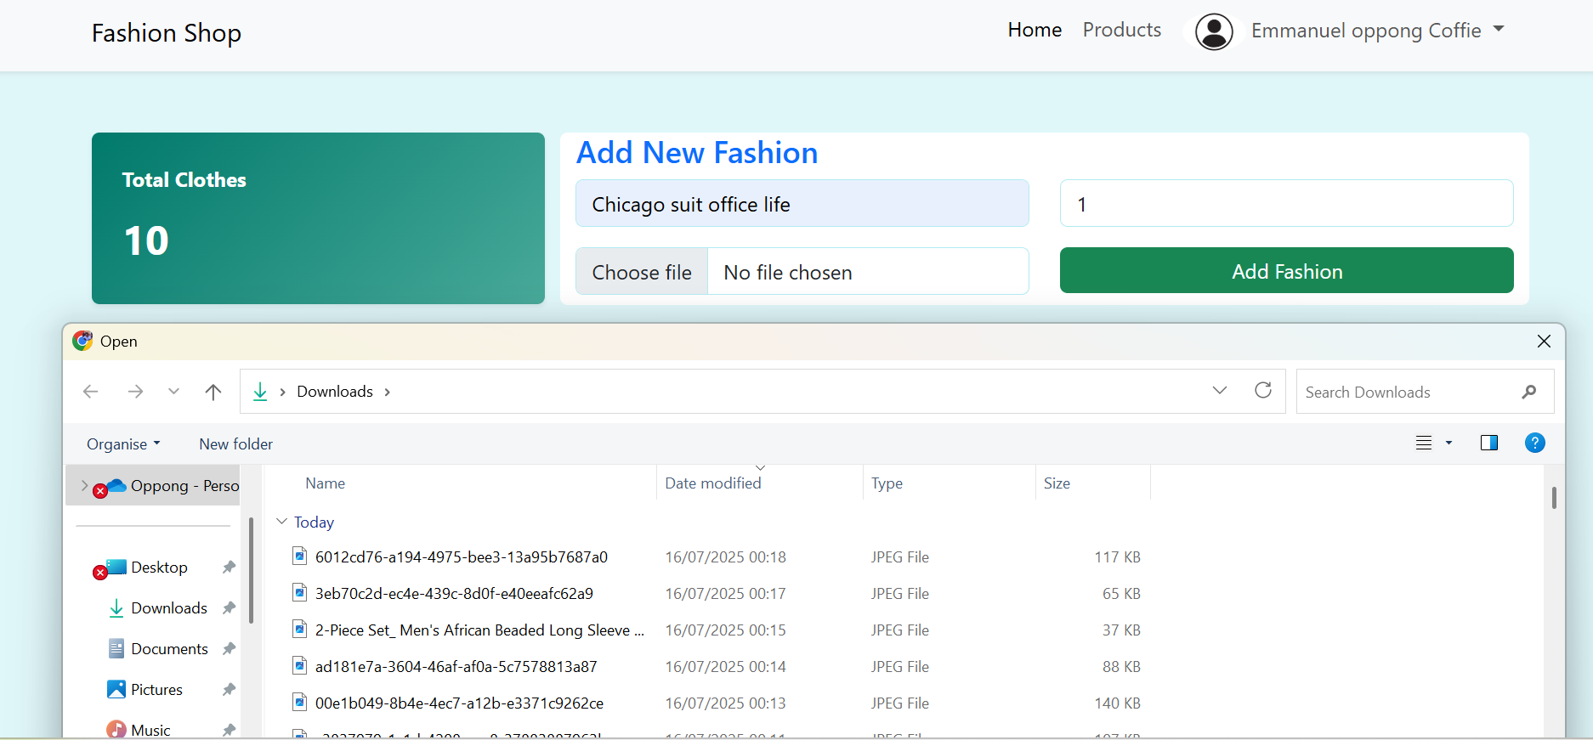

**4.2.5 WhatsApp Chatbot and AI Assistant**

An integrated AI-powered chatbot (via BotPress and OpenAI) is available on both the website and WhatsApp to handle customer inquiries, suggest designs, and offer order assistance.  
A floating chat widget on the site launches a conversation with the bot. It responds to queries like “What should I wear to a wedding in Takoradi?” with context-aware suggestions.

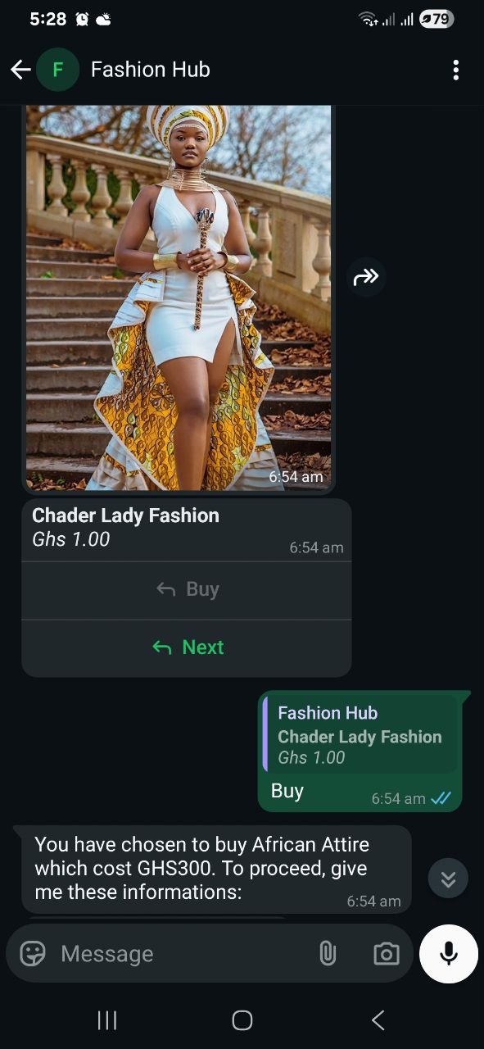 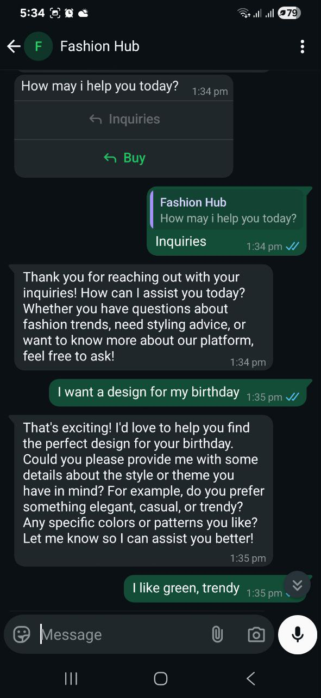

### ****4.2.6 Product Details Interface****

The Product Details Interface allows customers to view individual fashion items in detail. It displays a large product image, item name, price (in GHS), and a clear description including size, material, and intended use. Users can add the item to their cart or proceed directly to checkout.

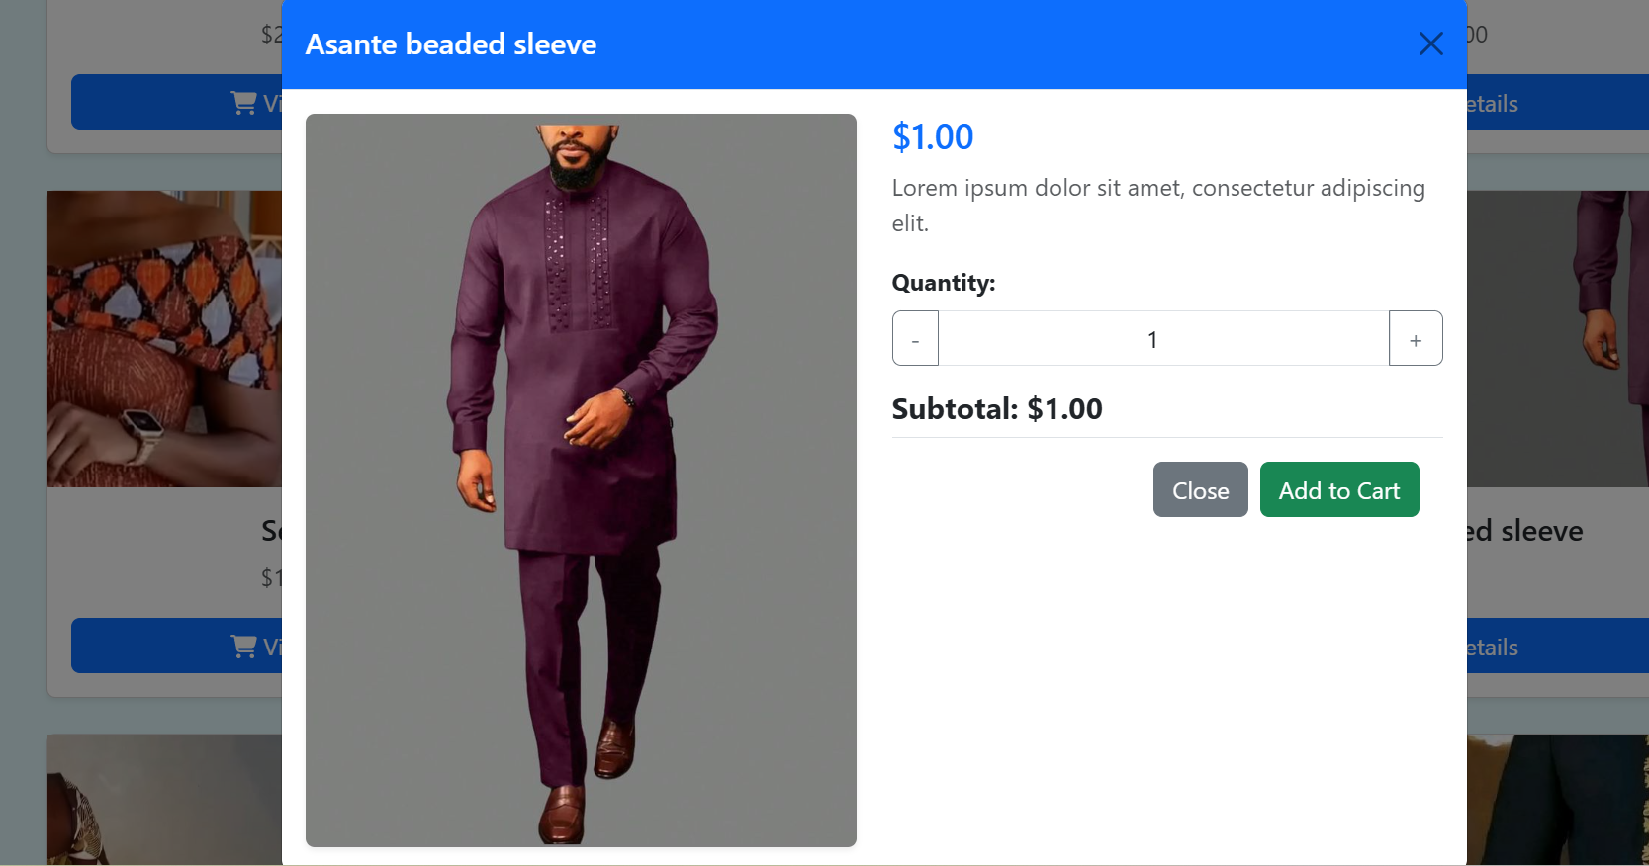

### ****4.2.7 Checkout Interface****

The **Checkout Interface** is designed to offer a smooth and secure purchasing experience. After selecting products, users are directed to a simple page summarizing their order, including product name, quantity, price, and total cost.

Customers can then enter their shipping details and proceed to payment using **Paystack**, which supports mobile money and card payments. Upon successful payment, a confirmation message is shown, and both customer and vendor receive email or in-app notifications.

The interface is mobile-friendly, loads quickly, and minimizes steps to reduce drop-offs. Test users appreciated the ease of use and secure payment options, which increased their trust in the platform.

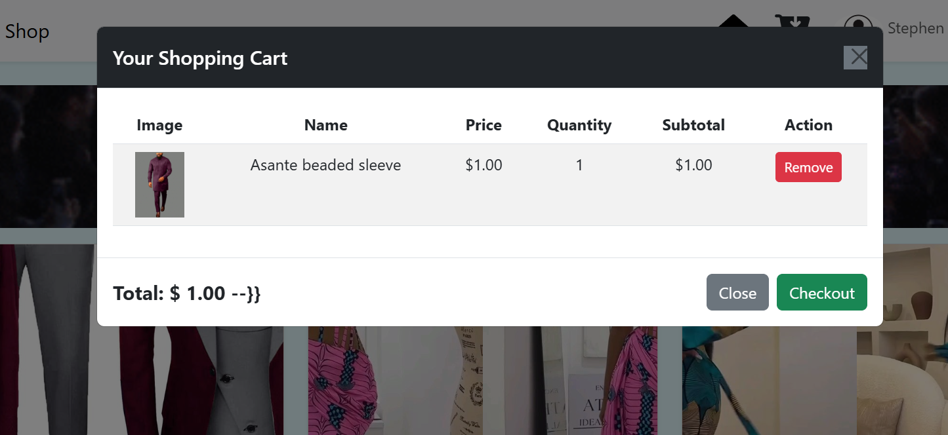

**4.2.8 Designer’s Product View**

The designer’s product view provides a straightforward interface for boutique owners to manage their items on the platform. Each product is displayed with its image, name, and price, along with options to either edit or delete it. The edit feature allows designers to update existing product details through a pre-filled form, making changes quick and convenient. The delete function lets them remove products, with a confirmation prompt to prevent mistakes. This interface is mobile-responsive and easy to navigate. During testing, designers found it simple and effective for keeping their product listings up to date.

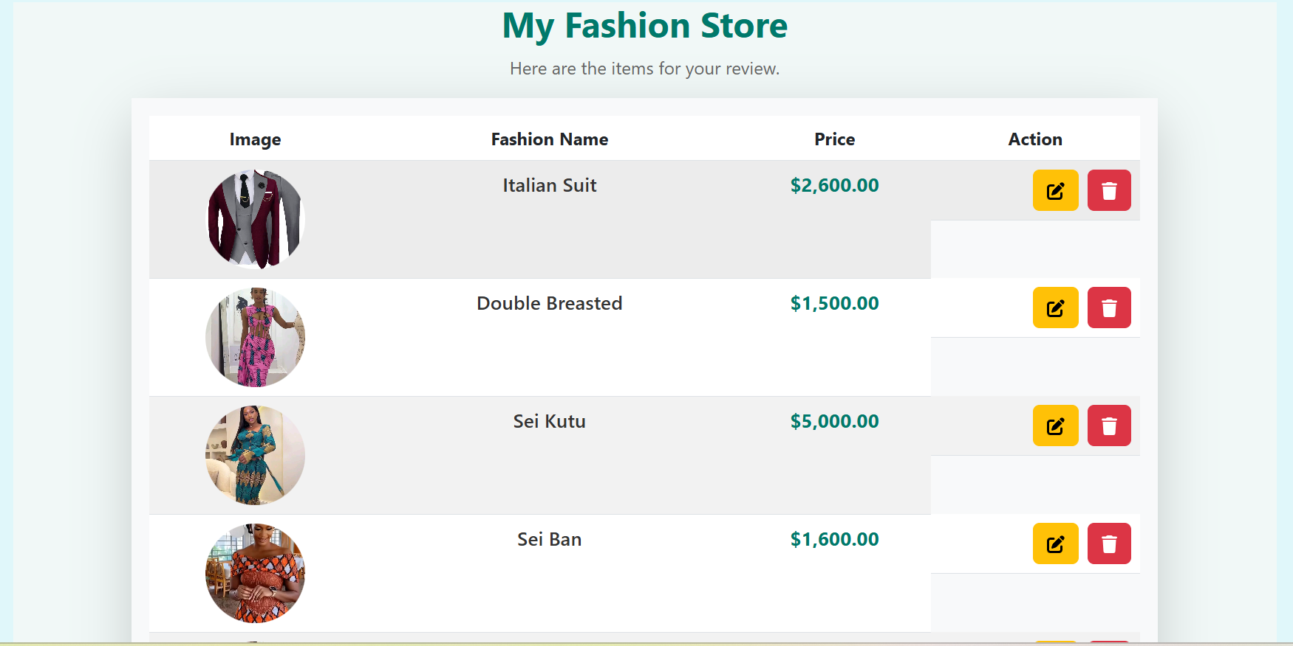  
  
**4.4.3 Edit Product Interface**

The edit interface allows designers to update existing product information quickly and easily. When a designer clicks the "Edit" button, a pre-filled form appears containing the product’s current details, including name, price, description, and image. This enables the designer to make changes without re-entering all information. The form is styled for clarity and responsiveness, working well on both desktop and mobile devices. After editing, the updated details are saved to the database, and the changes reflect immediately on the storefront. During testing, designers appreciated the simplicity and speed of the editing process.

### 

## 4.2 Discussion of Results

The results of the study also align with the research questions outlined earlier, offering insight into the challenges, needs, and user experiences of fashion entrepreneurs in Takoradi.

Regarding the first research question, which focused on the key challenges faced by boutique owners and designers when trying to expand through online platforms, the findings revealed common issues such as low digital literacy, insecurity around online payments, and weak customer engagement. The Fashion Hubplatform addresses these challenges directly by offering a clean, easy-to-use interface and integrating mobile money payments, which lowers the entry barrier for non-technical users and builds trust in digital transactions.

For the second research question, which explored the required features for effectively showcasing and managing fashion products online, the study found that local entrepreneurs value simplicity, control, and mobile accessibility. The vendor dashboard, image upload system, and product management tools were well received by testers, who noted that these features were both relevant and easy to use, even on mobile devices.

The third research question focused on how e-commerce functionalities like secure payments, shopping carts, and order tracking could improve business operations. In response, the integration with Paystack proved highly effective. It enabled secure, fast payments and eliminated the need for vendors to manually verify transactions. Real-time order confirmations and status updates also helped reduce confusion and improved customer satisfaction.

The fourth question investigated the role of AI-powered tools in supporting customer interaction and fashion ideation. Test users responded positively to the chatbot integrated on both the website and WhatsApp. They particularly appreciated the AI design assistant’s ability to suggest outfit ideas based on factors such as occasion and weather. This feature was considered especially useful by customers preparing for special events.

Finally, in response to the fifth research question on user suggestions for platform improvement, feedback highlighted several areas for future enhancement. These included adding customer review sections, supporting listings for fabric-only products, and enabling direct messaging between designers and buyers. These suggestions will inform upcoming development sprints, following the Agile methodology adopted for the project.